Pokhara University

Level: Bachelor | Semester – Spring | Year : 2007
Programme: BE |  | Full Marks: 100
Course: Theory of Computation |  | Time : 3hrs.

Candidates are required to give their answers in their own words as far as practicable.
The figures in the margin indicate full marks.

Attempt all the questions.

 | - Define NFA. Given NFA is  Convert it into its equivalent DFA.  - Find the regular expression for the following NFA.  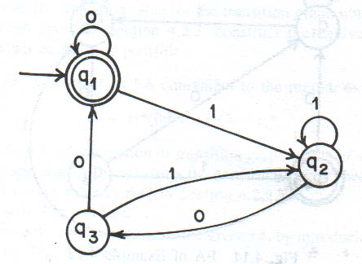  OR  Construct Non Deterministic Finite Automata (NDFA) for the following regular expressions:  - 10*01*  - (10*1 + 01*0)  - (ab + aab)*  - int xyz;  - (a+b)*(aa+bb)(a+b)* | 7  8  8
  δ/ | a | b
  q0 | {q1.q2} | {q2}
  q1 | {q0} | {q1}
  *q2 |  | {q0,q1}
 | - Show that regular sets are closed under intersection.  - Write a CFG which generates balanced parenthesis.  - Show that L={a^{n}b^{n} | n>=1} is not regular. | 5  5  5
 | - Consider a grammar G = (V, T, P, S) where  V = {S},  T = {a, b}  P = {S aABb  A Aa/a  B bB/b }  Test whether the given grammar is Context free or not.  - Show the grammar S→a/abSb, A→bS/aAAb is ambiguous.  - Define ambiguity in context free grammar. Reduce the following grammar G into Chomsky normal form (CNF).  - A->X₁X₂X₃…X_{n}  - A-> x₁x₂x₃…x_{n} | 5  5  5
 | - What do you mean by pushdown automata? Discuss its power in accepting languages in relation to finite automata.  - Construct a Push Down Automata for the following language.  L = {a^{n} b^{2n} / n = 1, 2, 3…}  OR  Construct PDA accepting following language: L={wcw^{T} | w € {a,b}*} | 7  8  8
 | - Can you simulate general purpose computer with Turing Machine? Explain.  - Explain decision algorithm for context free languages.  - Design a Turing machine that accepts the language: L= 1^{n}2^{n}3^{n} / n ≥0. | 5  5  5
 | - Explain time complexity and space complexity.  - What are NP complete problems? Give some examples of NP complete problem. | 7  8
 | Write short notes on (Any Two):  - Universal Turing machine  - Closure properties of regular sets  - Church’s hypothesis  - Decidability | 2×5

